Fast

**National University of Computer and Emerging Sciences, Karachi**

**FAST School of Computing  
Quiz # 1  
February 28, 2022**

|  |  |  |
| --- | --- | --- |
| **Course Code: CS3005** | **Course Name: Theory of Automata** | |
| **Instructor Name: Mr. Musawar Ali** | | |
| **Student Roll No:** | | **Section No:** |

**Instructions:**

* Read each question completely before answering it. There are **5 questions** on **2 pages.**
* In case of any ambiguity, you may make assumption. But your assumption should not contradict any statement in the question paper.
* **Cutting and over-writing is strictly discouraged.**

**________________________________________________________________________________________**

**Total Time**: 30 minutes **Maximum Points**: 30

**Question # 1 (5 Points)**

**CCa, in this lexical analyser would get confused so this is not valid alphabet.**

**Question # 2 (5 Points)**

Let’s assume that we have a language what would be union of these languages.

**Question # 3 (5+5 Points)**

Write down the RE for following languages.

1. {
2. Language of the words that **start with aaa and end with abbb** and have **bbb** as a substring.

**Question # 4 (5+5 Points)**

Design the FA for following languages

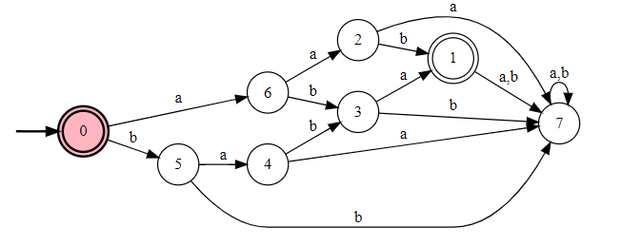

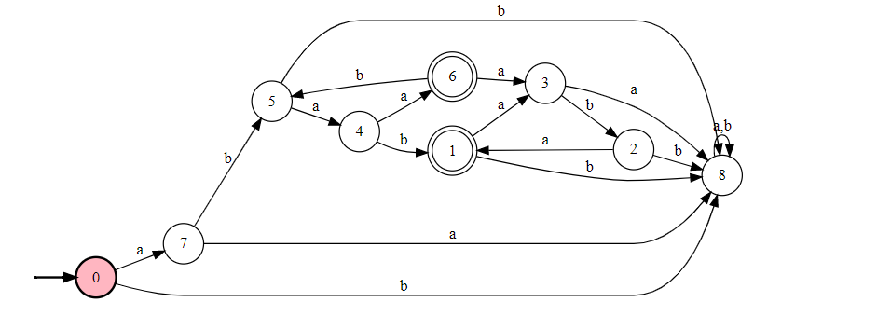

**Question # 5 (5 Points)**

Convert the following NFA to DFA.

This is dfa already

